**ASSIGNMENT 1.7**

We have a dataset of sales of different TV sets across different locations.

Records look like:

Samsung|Optima|14|Madhya Pradesh|132401|14200

The fields are arranged like:

Company Name|Product Name|Size in inches|State|Pin Code|Price

There are some invalid records which contain 'NA' in either Company Name or Product Name.

**2. Write a Map Reduce program to calculate the total units sold for each Company.**

**Task3.java**

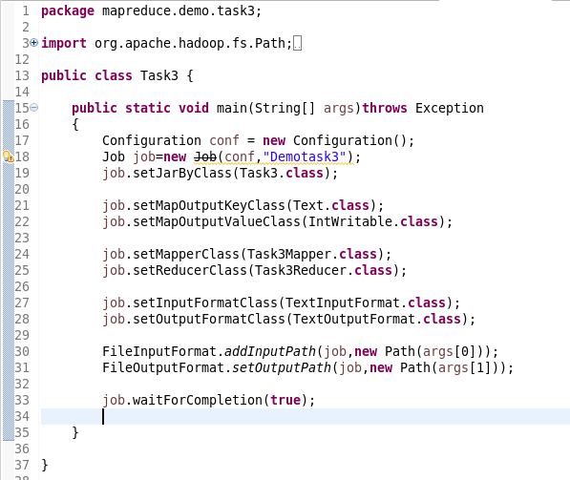

**Task3Mapper**

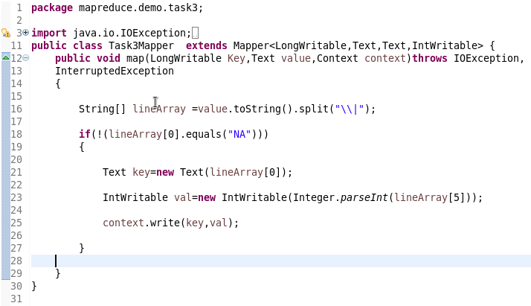

**Task3Reducer**

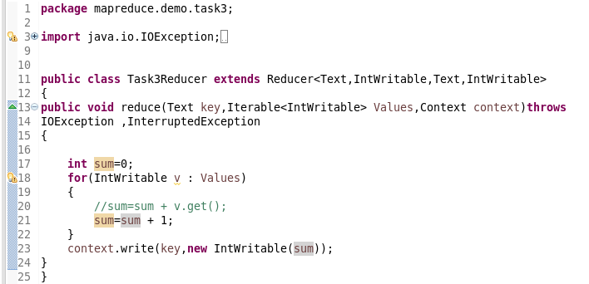

**Output**

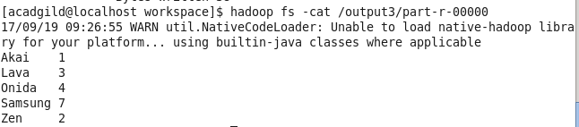

**3. Write a Map Reduce program to calculate the total units sold in each state for Onida company.**

**Task4.java**

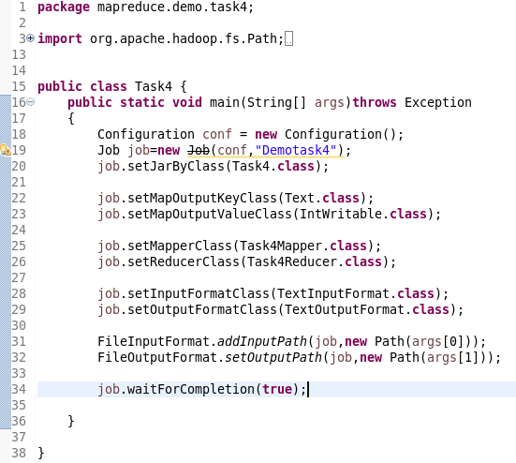

**Task4Mapper**

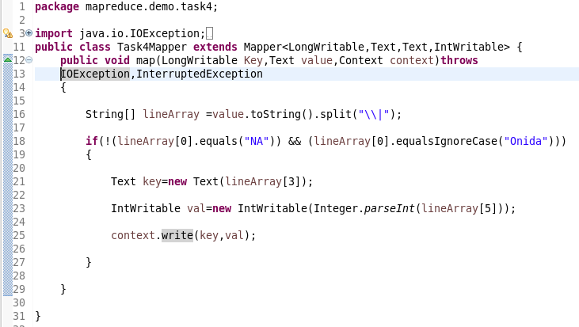

**Task4Reducer**

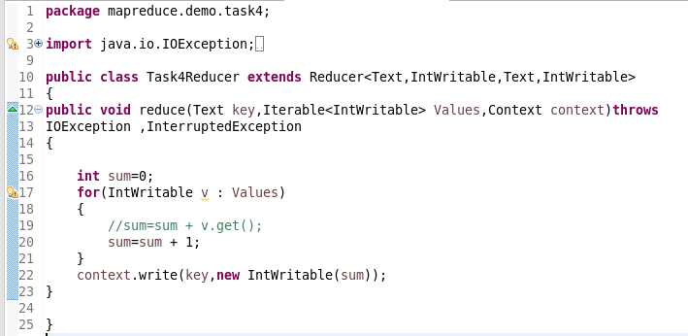

**OUTPUT**

